Strategy 1: CCI+MACD

WHY: I think that when we can't refer to the external market conditions, short-term (high-frequency) trading is needed to capture small fluctuations if we want to make a profit. In this case, I formulated a strategy with CCI as the core and MACD as the auxiliary. CCI is a sensitive indicator, so I hope to use it as a guide for my short-term trading. At the same time, I want to add the MACD indicator, because I think this can be a long-term control of my method to avoid the short-sightedness of the market, so that my strategy can remain calm even when the market is crazy. Another advantage is that I hope that in this way, my strategy can perform well regardless of whether the volatility is large or small. In addition, since CCI is generally regarded as a better indicator of market entry rather than exit([CCI Trading Strategies | All you need to know | Avatrade](https://www.avatrade.co.uk/education/technical-analysis-indicators-strategies/cci-trading-strategies#6)), I decide to let MACD be the main signal for selling, while CCI mainly used as a buy signal.

Considerations:

1. Using EMA or SMA in MACD indicator?

SMA. In my strategy, MACD is used in long-term trading. In the circumstance of SMA put all data in the equal weight while EMA give more weighting to recent prices, I believe SMA is more suitable for me, because this calculation method may imply that EMA is more suitable for short-term investment, while SMA is more suitable for long-term investment.

1. RSI or CCI?

RSI tracks the speed of price changes to observe overbought and oversold conditions, while CCI focuses on the normal deviation from the asset's moving average price to find deviations from the normal trend cycle. [Relative Strength Index vs. Commodity Channel Index: What's the Difference? (investopedia.com)](https://www.investopedia.com/ask/answers/012015/what-are-differences-between-relative-strength-index-rsi-commodity-channel-index-cci.asp) Because the core idea of the CCI indicator is to observe the deviation between the price and the moving average, I think the coordination between CCI and MACD may be better, compared to RSI. (Test 1)

WHEN: The CCI is an unbounded oscillator, which means that it can rise or fall indefinitely, and it can perform well even under extreme continuous rise and fall. In particular, in time series 5, I observed a continuous rise, and in time series 2 and 10, there was a shock drop. I think my strategy may achieve better performance in these three time series.

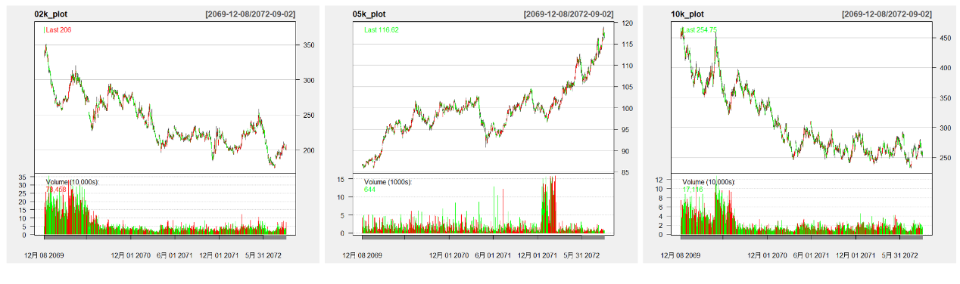

But like any other strategy, when the price fluctuates repeatedly within a range, it may suffer losses due to the inevitable lag of the indicator. So I think it should not be applicable to time series 4 with the highest volatility. For the remaining time series, I don't expect too high or too low profit.

HOW:

Parameters are as follows:



For convenience, I directly add the relevant data required by functions to the example_params list of example_strategies.R in the above form. Since the adjustment and testing of this part of the data requires a very high level of understanding, I will leave them as default for the time being, and plan to make adjustments in the next stage. For series, as I analyzed, time Series 4 does not apply to my strategy, so I do not consider it.

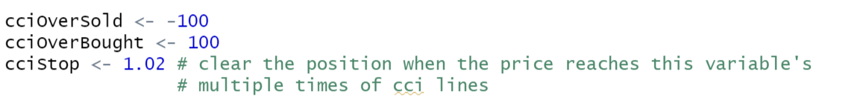

Compared with the previous part of the parameters, this part of the parameters is closely related to the strategy idea, so I put them in the front of the strategy document instead of example_strategies.R.

I kept the overbought and oversold lines of the CCI indicator as the default values, but I explored the value of the cciStop parameter (the process is recorded in test 2).

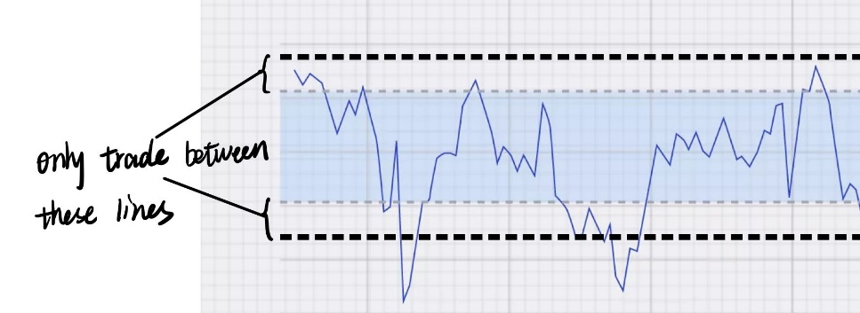

The core idea of using cciStop to stop loss is to add two more lines to the original two CCI lines to become two pairs. Since this part of my strategy is trend-following, buying between the two lines of each pair can stop the loss when the trend reverses.

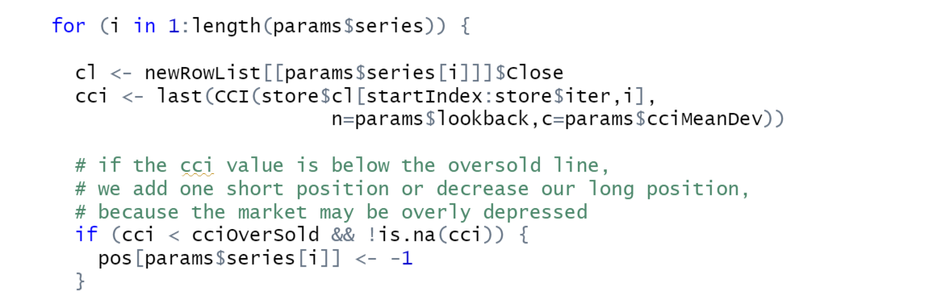

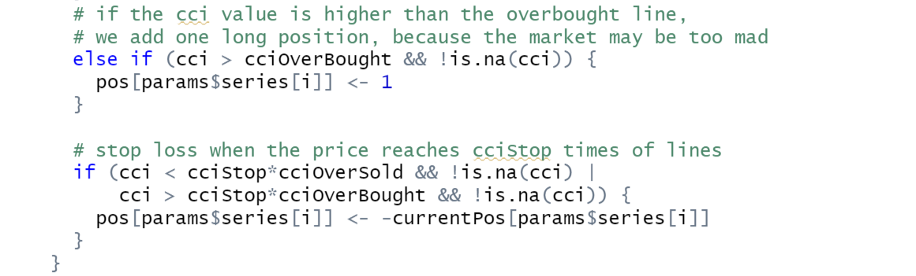

The above is the code of the CCI indicator. The following is the code of the MACD indicator, which treats signal>macd value as a sell signal to lighten up the position. Only TTR functions are used.

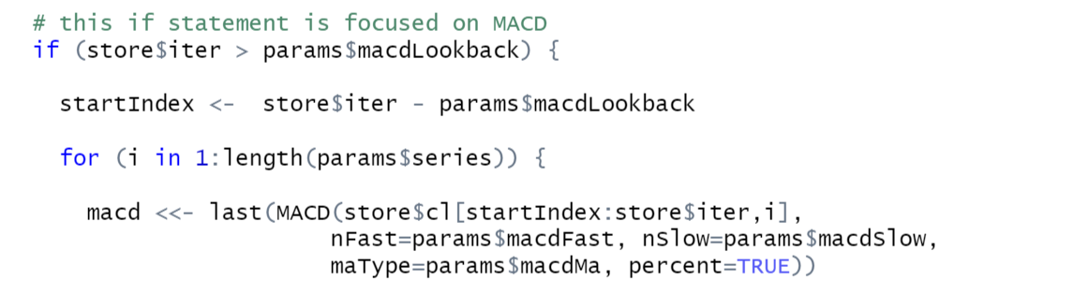

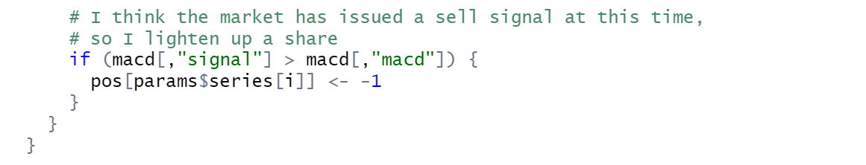

Tests:

1. A 500-day out-sample test on the performance of RSI and CCI respectively, with the same parameter of 20 days lookback and the same MACD settings.

RSI:

Core code:



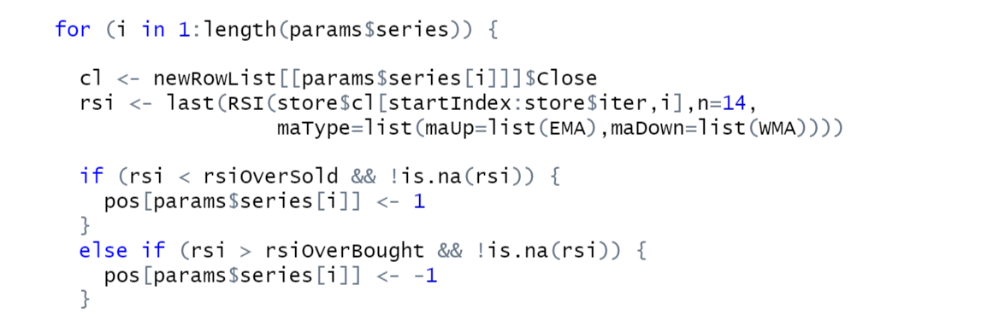

Result:

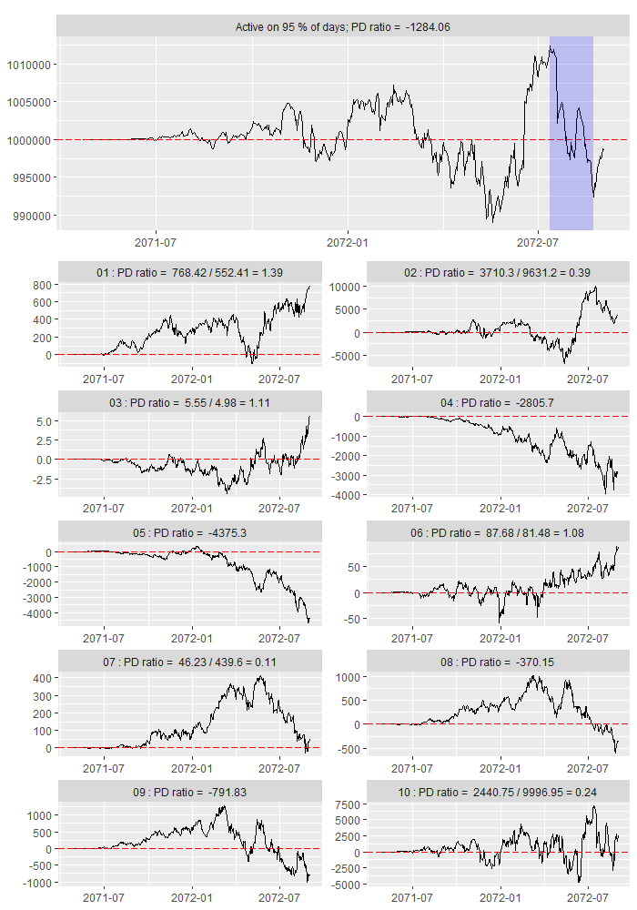

CCI:

Core code has been shown in previous part.

Result:

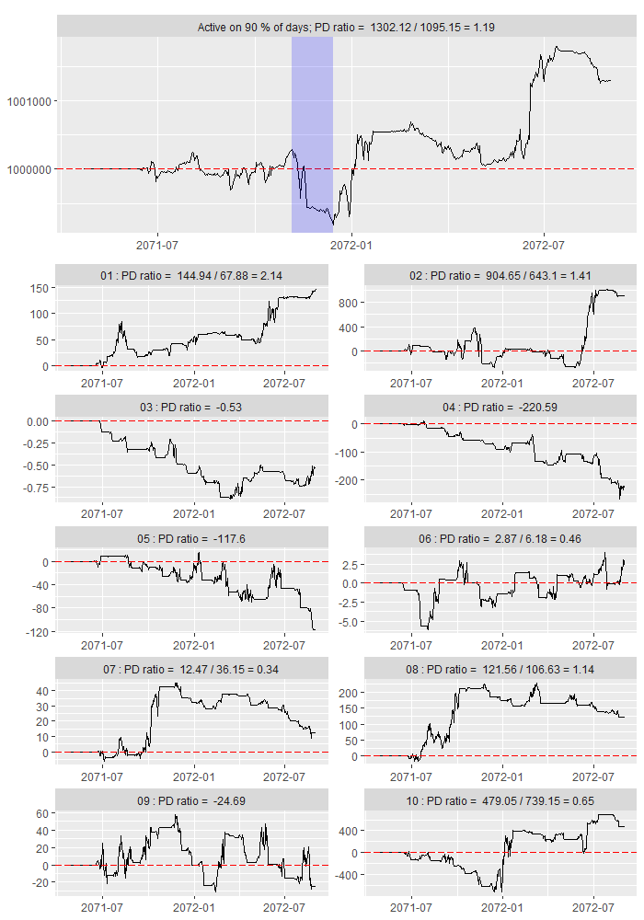

When using the CCI indicator, a small part of the time series will have good gains, and another small part will have some loss, but not much. The remaining time series mostly hover around 0. However, when using the RSI indicator, nearly half of the time series showed high losses, which was very unstable.

In summary, CCI may be better in my strategy.

1. Test the effect of the change of cciStop value on the overall PD ratio (both in in-sample and out-of-sample).

Result:

|  |  |  |
| --- | --- | --- |
| cciStop | In-sample PD | Out-if-sample PD |
| 1.1 | 0.43 | 0.62 |
| 1.09 | 0.53 | 1.12 |
| 1.08 | 0.53 | 1.16 |
| 1.07 | 0.65 | 1.19 |
| 1.06 | 0.65 | 1.18 |
| 1.05 | 0.65 | 1.13 |
| 1.04 | 0.88 | 1.18 |
| 1.03 | 0.89 | 1.18 |
| 1.02 | 0.89 | 1.19 |
| 1.01 | 1.01 | 1.12 |

I have marked the highest value in the two columns. In summary, we can find a trend in the in-sample data column that the closer the cciStop is to 1, the better the overall PD performance. But somehow, out-of-sample data does not appear such a trend.

If only the current in-sample data is selected as the sample, there is no doubt that cciStop equal to 1.01 is the optimal. But considering that in the next stage we may use all the current PART 1 data as the sample, and when cciStop=1.01, the out-of-sample PD performance is not good, I tend to choose 1.02 as the final cciStop, as it has the best overall performance.

Risk Management:

Judging from the results of multiple tests, I think that my strategy is unlikely to cause bankrupt, which may be due to the stricter stop loss conditions. My strategy will only be in the overbought zone and oversold zone of CCI for buying transactions. However, regardless of whether the price is in the overbought or oversold area of CCI, my cciStop line is only 1.02 times the overbought and oversold lines, which means that I will only earn/loss 2% per transaction. Although this limits the possibility of more profits, it also reduces losses.

My position management is automatic. When the CCI trading rules are triggered, it will buy or sell/short 1 unit. When the stop loss rule is triggered, the position is cleared directly. When the MACD rule is triggered, it will sell/short 1 unit, because the current market may be too mad.

Plan:

1. After getting the data of PART 2

I will immediately use the new data to test my strategy and check the profitability. If the return is not good, I will reconsider the overall structure of the strategy. If the benefits are acceptable, I will continue to consider the fine-tuning of strategies such as parameter optimization. Considering the group as a whole, I will discuss with the group members how to combine different strategies more effectively, such as funding allocation and strategic priority issues.

1. Parameter optimization

As I predicted in the "When" part, my strategy performed the worst on the fourth time series. But unlike my prediction, my strategy not only failed to obtain overall positive returns on the time series 5, but even negative returns from the beginning.

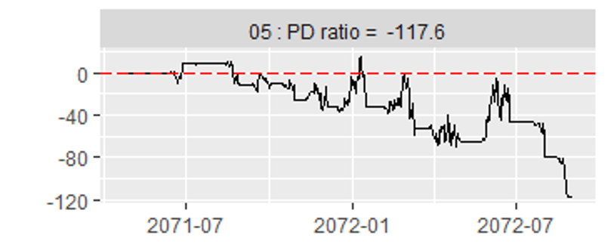

In theory, I think this is because the parameters of my MACD curve have not been adjusted, perhaps too strict and conflict with the existing CCI indicators. Thus, I plan to continue to research and optimize my parameters, especially the part that is the function parameter.

Specifically, I will study where the best CCI overbought and oversold areas are. Meanwhile, because the CCI indicator changes too fast, I hope to reduce the time required for the fast and slow lines of MACD so that MACD can "catch up" with changes in CCI to a certain extent. It cannot be too fast, which will lose the effect of the MACD indicator as a "sedative", but it cannot be too slow, which may send a signal opposite to the CCI and cause trading losses. I might first halve macdFast and macdLow to see the effect. Also, I will consider slightly reducing (increasing) CCI's lookback and increasing (decreasing) its mean deviation to make the indicator more agile (sluggish) if my strategy is tested bad with PART 2 data.

1. In-sample/out-of-sample test

With three years’ data in total, I prefer to use one year's data as sample, and the remaining two years as out-of-sample. Because usually one year's data is considered to be a "complete" data, and many characteristics are usually better reflected in the time of the year.

1. My strategy currently does not use limit orders, and I plan to continue to consider this issue in the next phase.
2. My current strategy does not include the "divergence" consideration, I hope it can be completed before the integration strategy.

Reference:

<https://www.investopedia.com/terms/c/commoditychannelindex.asp>

<https://www.youtube.com/watch?v=E3KP1WyLITY>

<https://www.dailyfx.com/education/technical-analysis-tools/macd-indicator.html>

<https://www.abhijitpaul.com/rsi-and-cci-combination-trading-strategy-for-phenomenal-returns/>

Strategy 2: KDJ+MACD

I heard that this combination is very effective when trading strong stocks, and I will do research later.

Reference:

<https://www.bilibili.com/video/BV1jy4y1g7r2/?spm_id_from=333.788.recommend_more_video.-1> (Chinese)